Eskom Kimberley Strengthening Phase 4 Project: ULCO-OLIEN-MANGANORE
Photos of the macro study area
Detail site photos are provided in the specialists reports

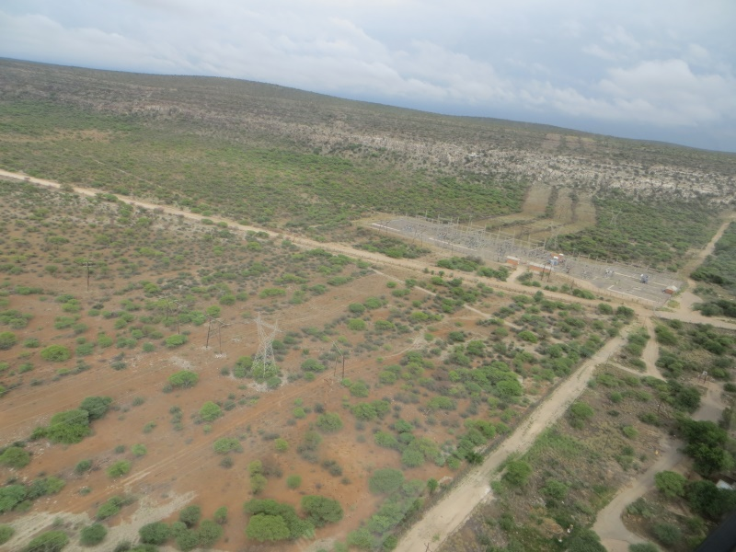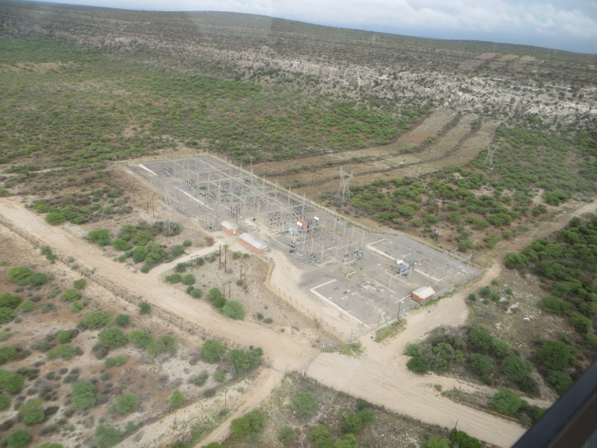
The Ulco Distribution Substation with the Gaarp Escarpment in the background.
Servitudes of existing lines where vegetation were cleared are clearly visible

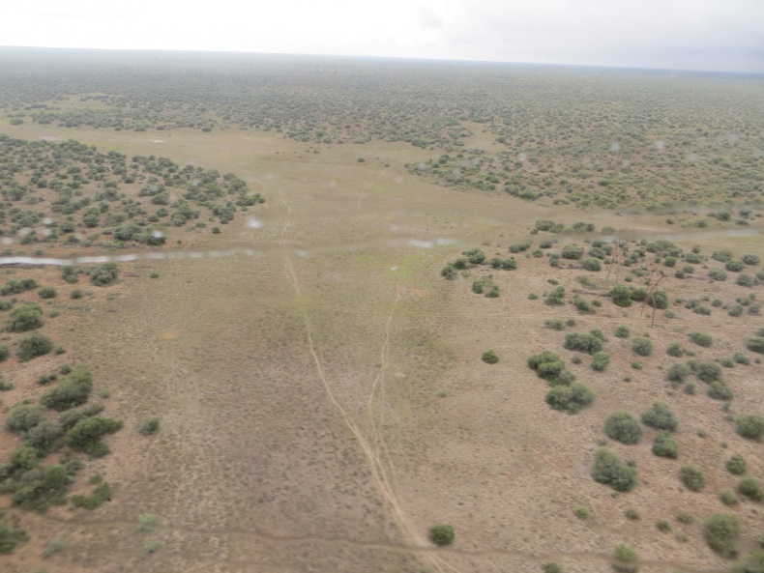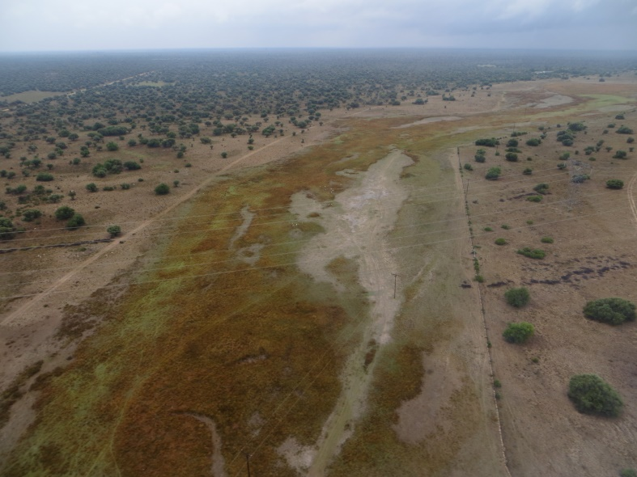
Route Alternative 3 – note that this route was discarded as it followed the Klein-Riet River with its associated valley bottom wetlands and impacts would have been unacceptably high

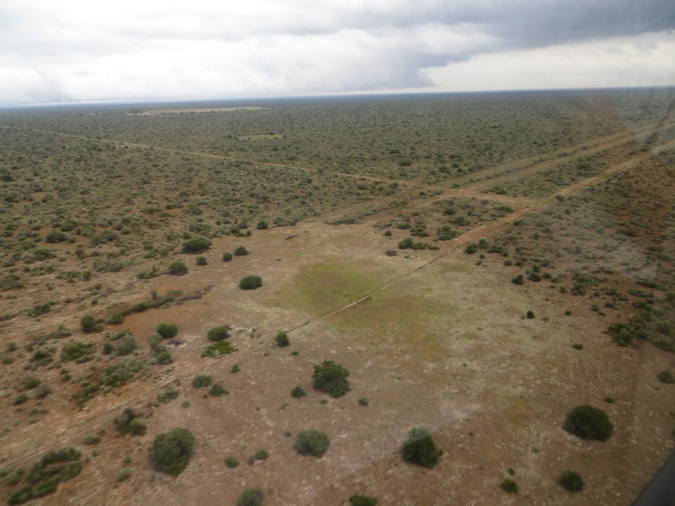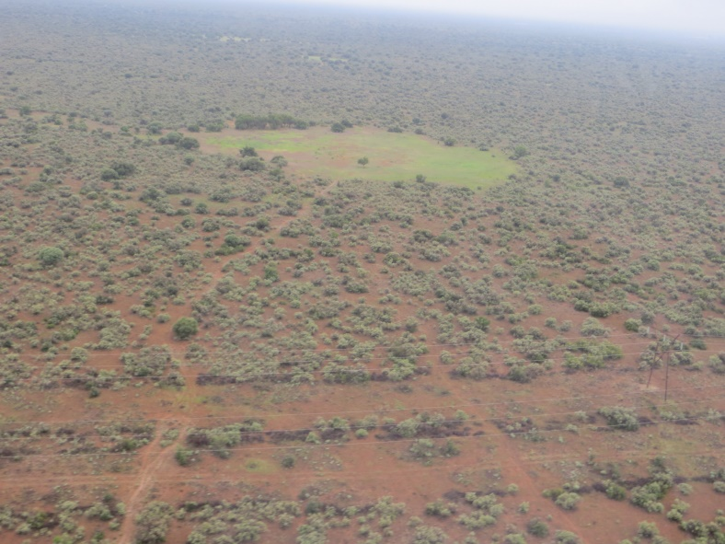
Typical views of the study area between the Ulco and Olien Substations. Pans and existing infrastructure such as roads, power lines and farm fences are visible throughout the landscape.

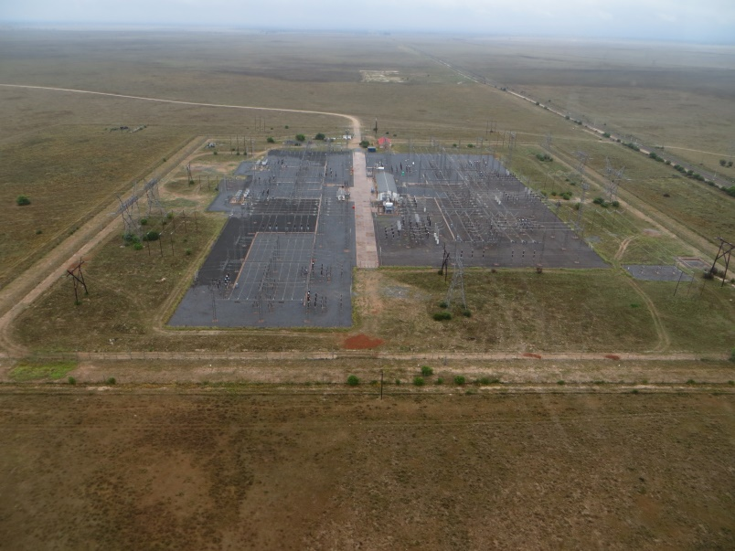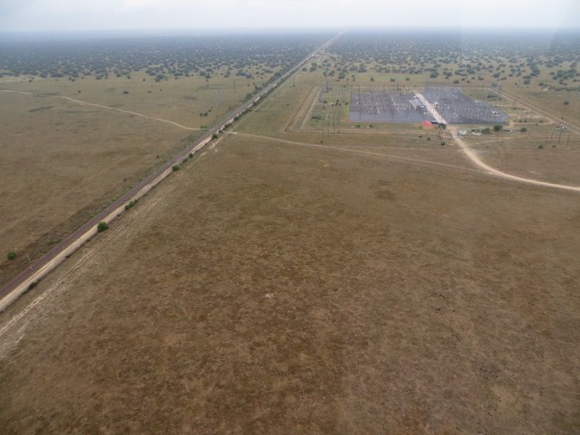
The Olien Distribution Substation

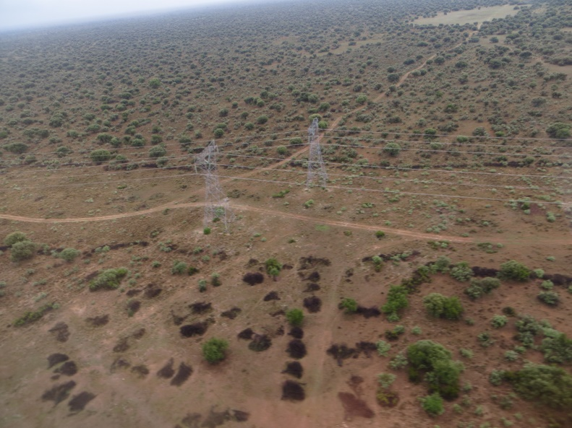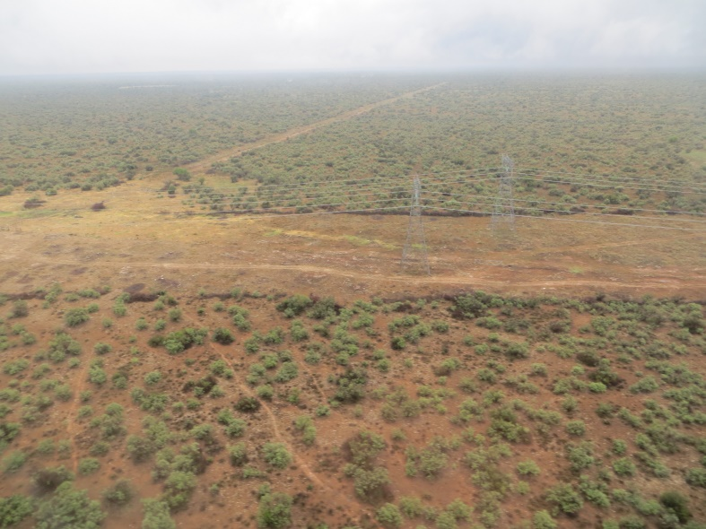
Existing infrastructure

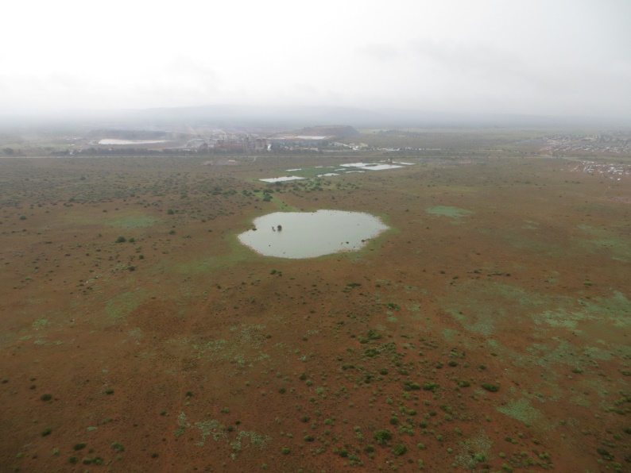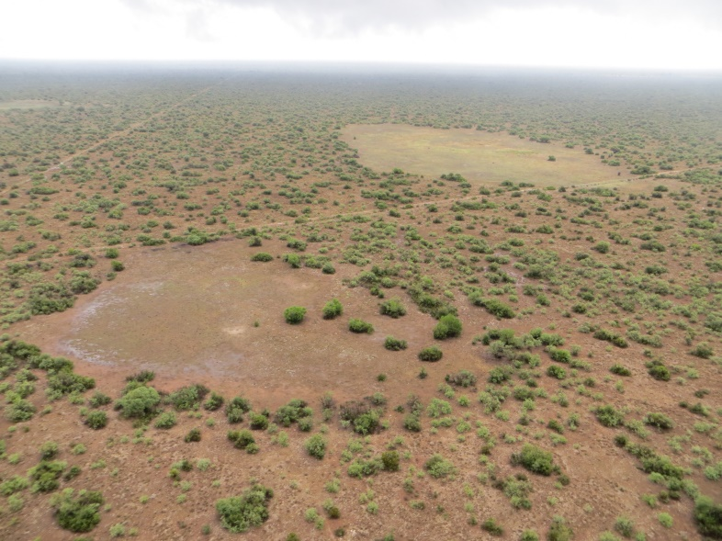
Pans within the study area

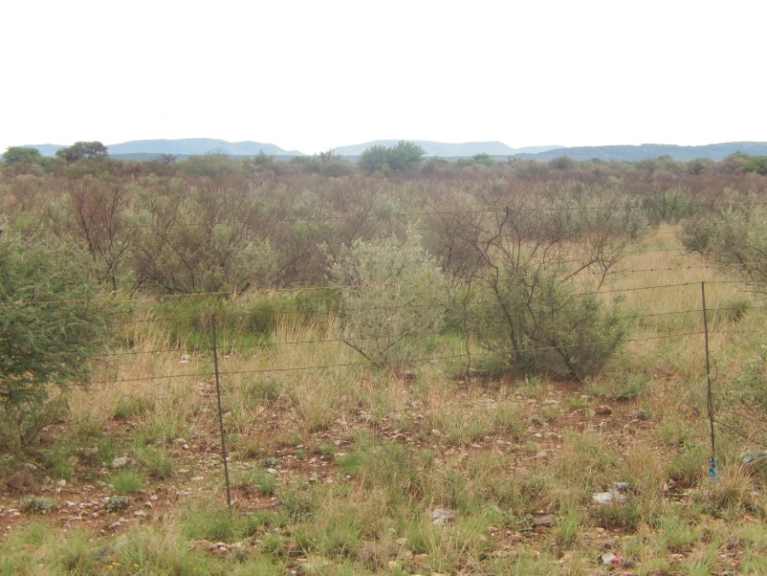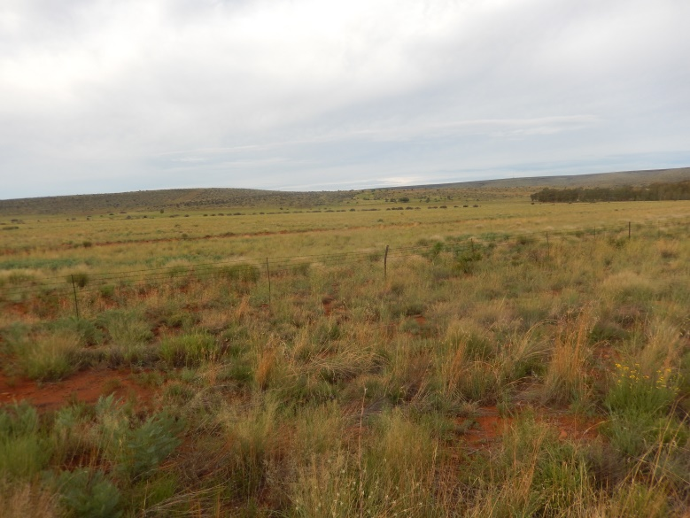
General view of the study area between the Olien and Manganore Substations

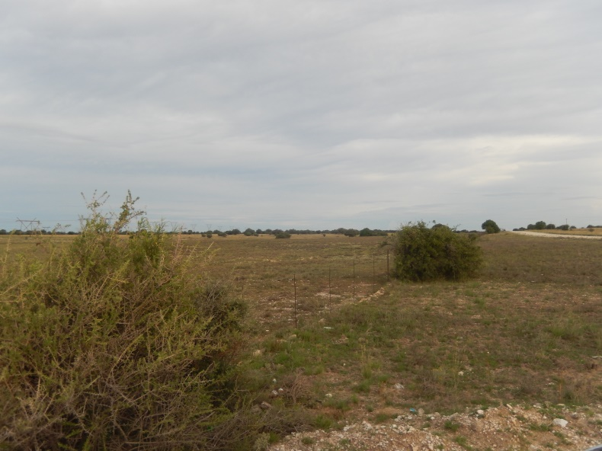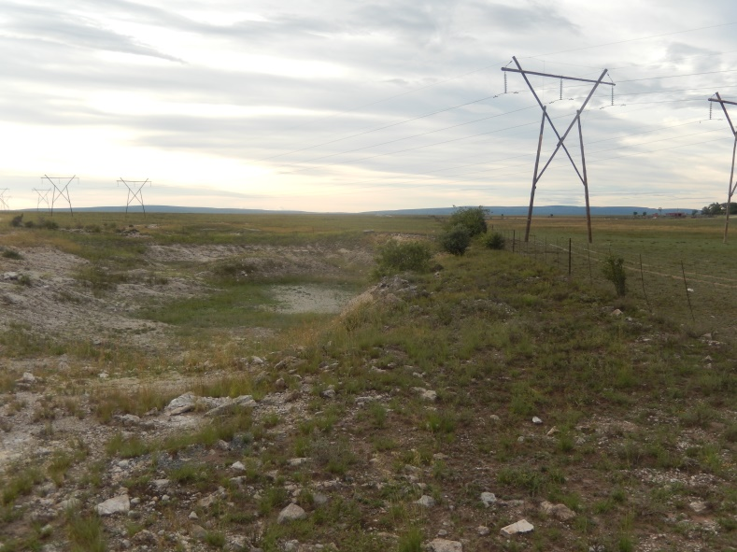
General view of the study area between the Olien and Manganore Substations

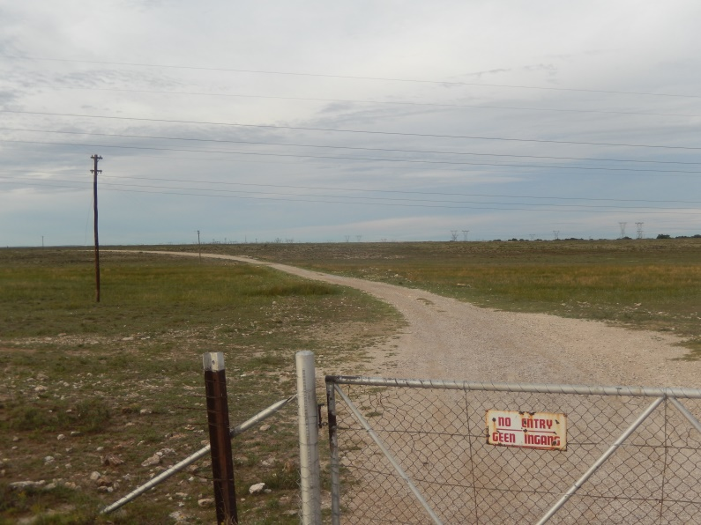 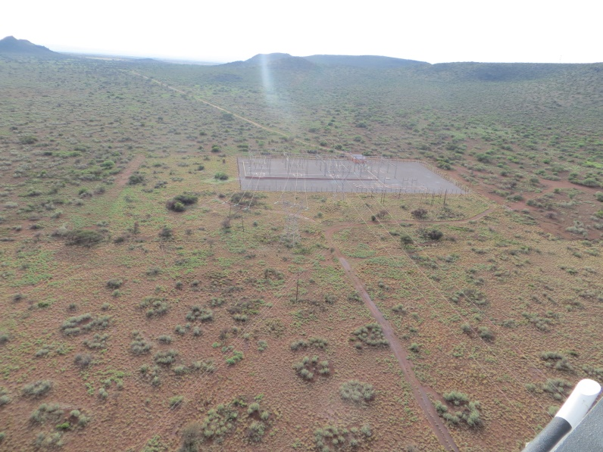The Manganore Substation

